# Task-1

## Question

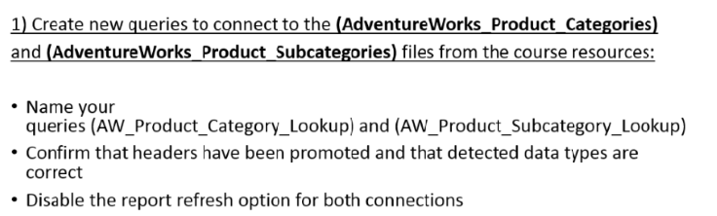

## Solution Screenshots

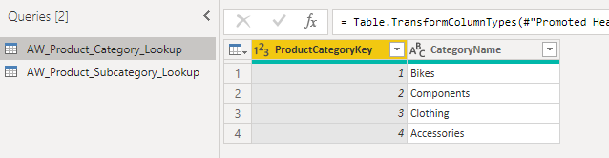

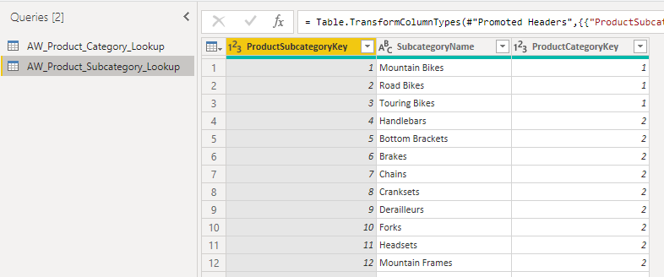

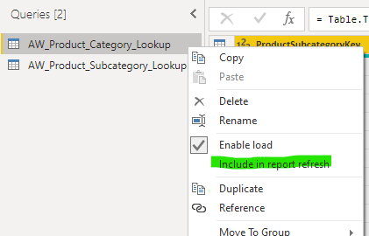

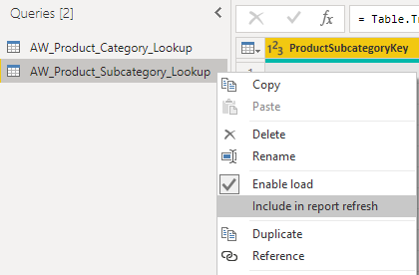

# Task-2

## Question

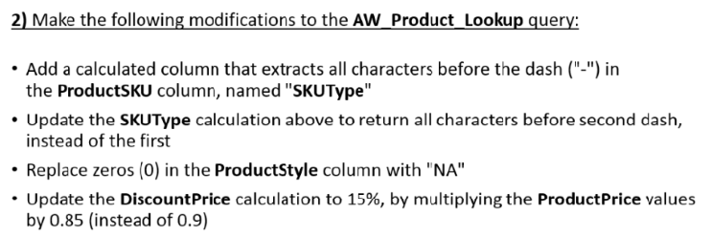

## Solution Screenshots

SKUType as characters before “-“.

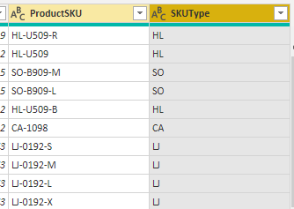

SKUType as characters before second dash “-“.

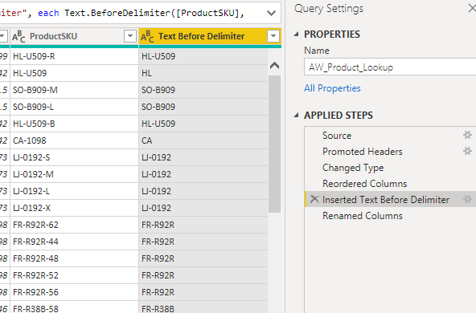

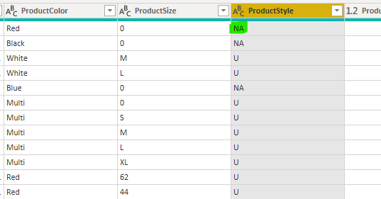

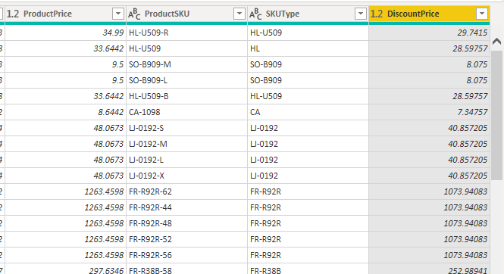

# Task-3

## Question

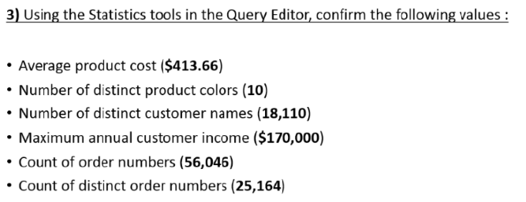

## Solution Screenshots

Average Product Cost

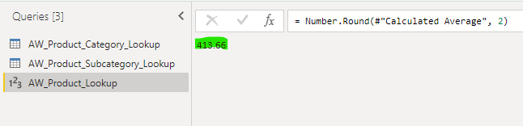

Number of Distinct Product Colors

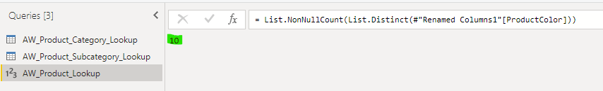

Number of Distinct Customer Names

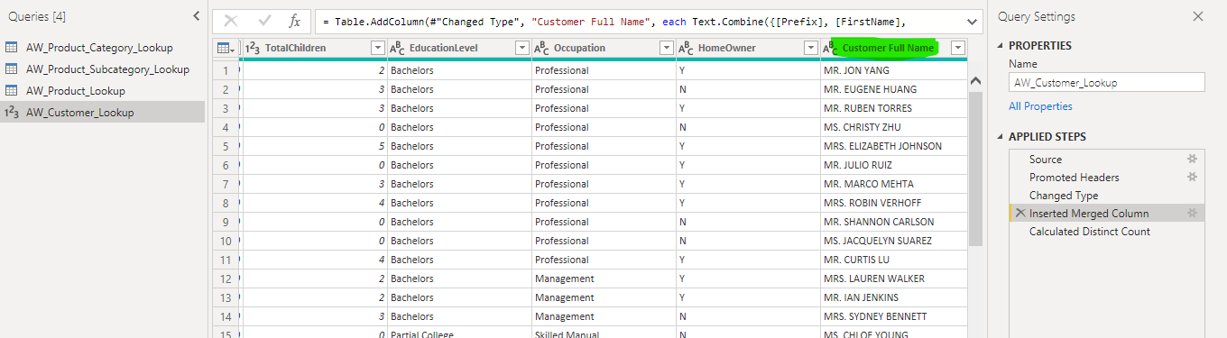

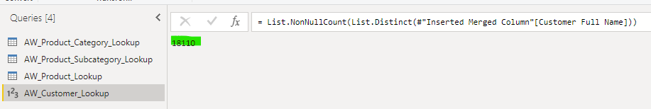

Maximum Customer Annual Income

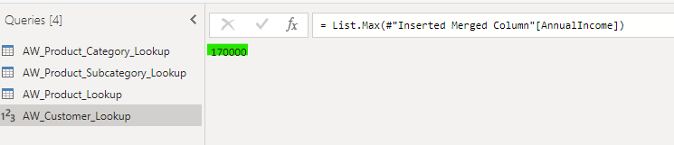

Count of Order Numbers

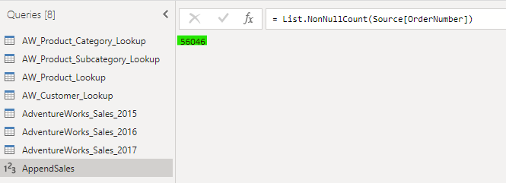

Count of Distinct Order Numbers

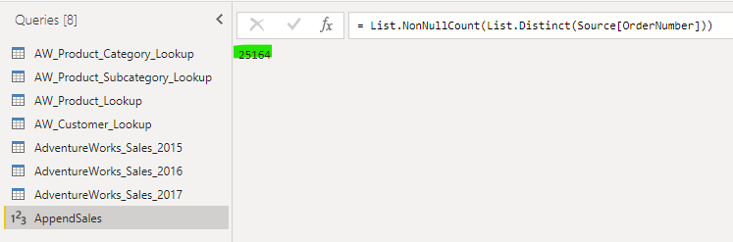

# Task-4

## Question

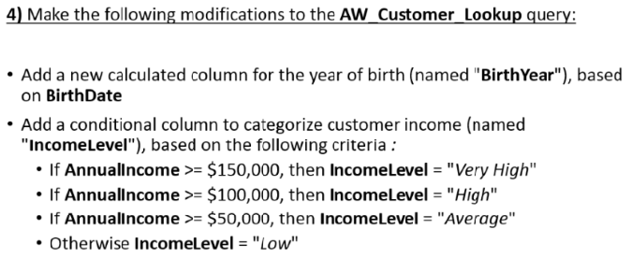

## Solution Screenshots

Extract Birth Year of Customer

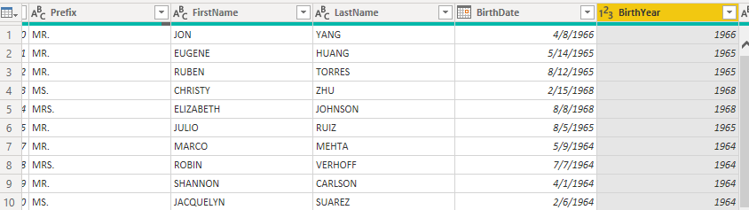

Categorize the Customer based on Annual Income

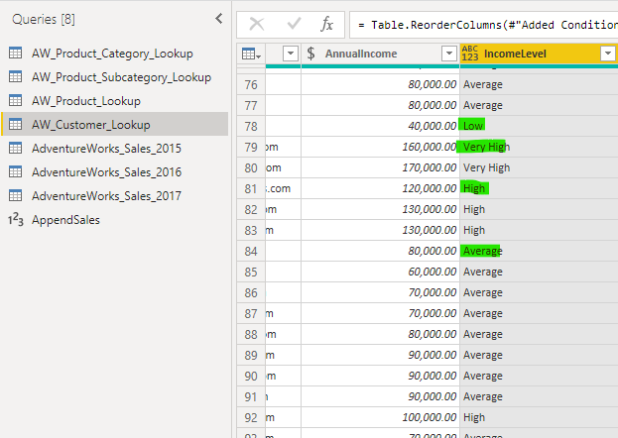

# Task-5

## Question

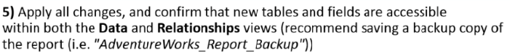

## Solution Screenshots

